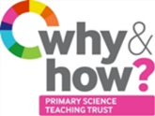
TAPS Plan for Focused Assessment of Science

Topic:  Animals including humans | Year 1  Age 5-6 |  | Title:  Body parts
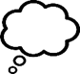  Working Scientifically  Review: Use observations and ideas to suggest answers to questions |  | Concept Context  Identify basic parts of the human body and say which part of the body is associated with each sense.
Assessment Focus
- Can the children observe and name parts of the human body?
- Can the children use their observations to say which part of the body is associated with each sense?
Activity Today you are an anatomist.
Play body part games e.g. Heads, shoulders, knees & toes, Simon says etc.
What parts of the body do you know? Point to parts on themselves or others.
Could look closely at body parts using magnifying glasses / mirrors (mouth, eyes, ears, noses) – are they all the same? What are these parts for?
Ask children to create a model (e.g. play dough or clay) of the human body and label the parts (head, neck, arms, elbows, legs, knees, face, ears, eyes, hair, mouth, teeth).
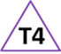
Describe which part is associated with each sense and explain what we use each sense for. Could label with different coloured paper or on a class/group model.

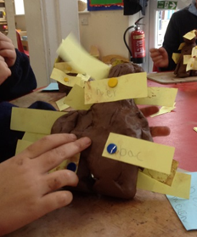
Adapting the activity
Support: Adult to ask the names for parts of the model and scribe.
Extension: To name other parts of the body including internal organs.
Other ideas: Make large models out of scrap. Make models of animals.

Questions to support discussion
- What different parts of the body have you made?
- What does that part of the body do?
- What does this part help us to do?
- Which part of the body helps us to smell etc?
- What do you think happens inside?
Assessment Indicators
Not yet met: When prompted can name some body parts but does not suggest what these parts might do.

Meeting: Can name a range of body parts. Can link body parts to senses, e.g. I can smell things with my nose.

Possible ways of going further: Can talk about differences and similarities of body parts. Can name some internal organs, e.g. heart, brain, lungs, stomach.

Teacher box 4 - gather evidence in a range of ways.
See TAPS pyramid for more examples

