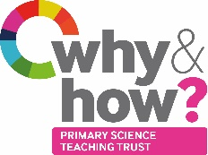
PUPIL VOICE QUESTIONNAIRE

Class / Year group: | ☺  Agree | 😐  Neutral | ☹  Disagree
I enjoy science lessons.
My teacher enjoys science lessons.
Science is difficult.
I do lots of thinking and talking in science.
I do lots of writing in science.
I use lots of equipment in science.
I work in small groups in science.
I would like to do more science lessons.
I can use some scientific words.
You must be clever to be good at science.

Extra questions:
How often do you have a science lesson?
What is science?
What do you like about science?
Is there anything that you do not like about science?
What has been your favourite science lesson?
How could your science lessons be better?

Note: Some questions will be more appropriate for some schools than others. Subject Leaders are encouraged to adapt this questionnaire to suit their school and the children.

