


TAPS Scotland

Focused assessment of scientific skills
Topic:  Body systems | Primary 4  Age 7-8 |  | Activity title:  Forensic fingerprints
Scientific skills focus    Carry out: observes and collects information |  | Curriculum link  I have explored my senses and can discuss their reliability and limitations in responding to the environment. SCN 1-12b
Assessment focus
- Can children collect information about their fingerprints?
- Can children observe closely to identify types and individual fingerprints?
Activity Today we are forensic scientists
Set up a mystery to solve e.g. linked with a story or a missing item in the classroom where some fingerprints were left behind. We need to become experts in fingerprinting to solve the mystery. Explore own fingerprints: close observation with magnifiers.
Take fingerprints e.g. can use ink pad or paint to make prints on paper, or use pencils and sticky tape (shade on paper, then rub finger on shading, capture print on sticky tape).
Can also put inked finger onto balloon then inflate to enlarge.
Identify type of fingerprint (arch, loop or whorl) using pictures from internet to compare with own.
Extra: dust for fingerprints e.g. use paintbrush to lightly dust cocoa powder onto surface covered in fingerprints, then ‘lift’ fingerprints with sticky tape.
Return to the ‘crime’ and compare crime scene fingerprints with suspects’ to find a match.
Note that a print may place them at the scene, but does not mean they are ‘guilty’.

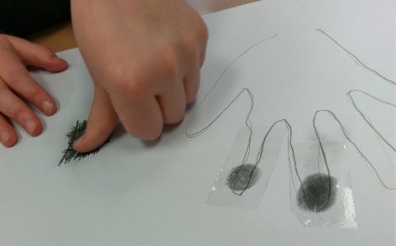
Adapting the teaching
Support: Provide pictures of arches, loops & whorl fingerprints.
Extension: Compare different methods for taking fingerprints. Consider level of confidence in evidence.
Other ideas: Consider other evidence left at the scene, e.g. left objects and fibres.

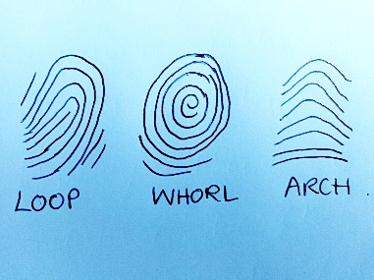
Questions to support discussion
- How did you collect your fingerprints?
- What type of fingerprint do you have?
- How are your fingerprints similar/different to X’s?
- What do you notice about the crime scene print?
- Which do you think is the best match? Why?
- How much confidence do you think we should have in this evidence?

Benchmark indicators
Working towards: Pupils explore their fingerprints, but struggle with close observation and comparison.

Achieved: Pupils observe closely, noting similarities and differences between the prints.

Possible ways to go further: Pupils begin to question the reliability of the evidence.

Pupil box 2 - focus on science objectives. See TAPS pyramid for more examples.

