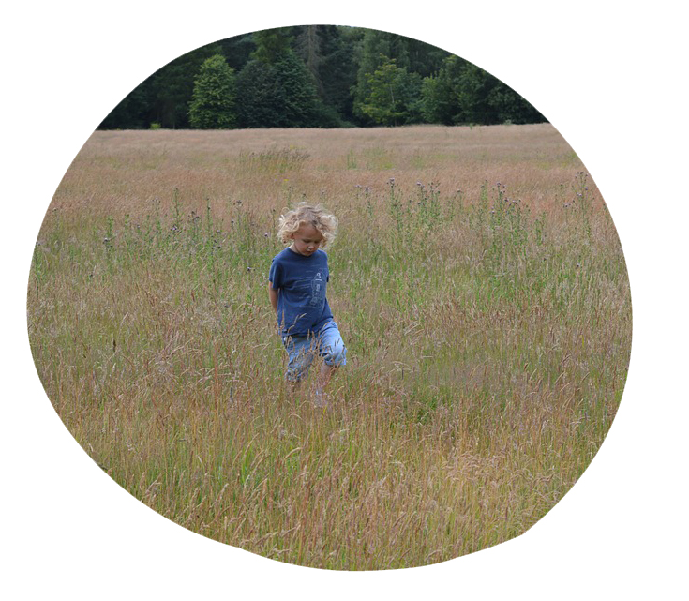

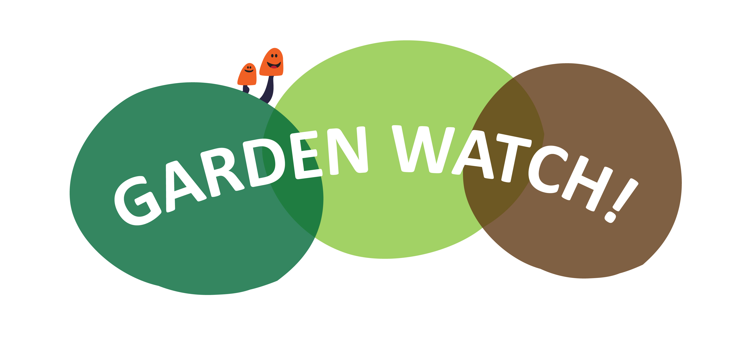

Dear Parents and Carers,

We have had a great response to our **‘Garden Watch’ challenge** survey!The information has now been collated and **here are the survey headlines…**

Home discussions around this information is great! Try asking/talking withyour child about the information that we (and you!) have collected…

* What did you see the most/least of? Was it what you expected?
* Is there anything that has surprised you?
* What do you think affected our surveys? (weather, time of day, season, other factors in the garden)

**TIME TO GET ACTIVE!**

Our next ‘**Garden Watch’** survey is due on date and the time in-between is time to *get busy in our gardens*. You can support the children by helping them to discuss, think about and decide they will do. Ask what wildlife do they want to attract? How can they do this? Why will *their* project attract wildlife?

There are lots ideas and links for activities and projects in the children’s ‘**Garden Watch’**booklets. There is also space in the book for the children to write, draw or photograph what they are doing in their gardens!

Don’t forget to keep us posted by following the project on Twitter (#GardenScience). You could also send questions, ideas, pictures or information to school via email (your address).

Our school ‘Garden Watch’ display will be updated regularly too, so keep an eye out for updates and information!

Thank you for your contributions to a project that will really make an impacting our community!

Warmest regards,

*The School name Team*

#Gardenscience