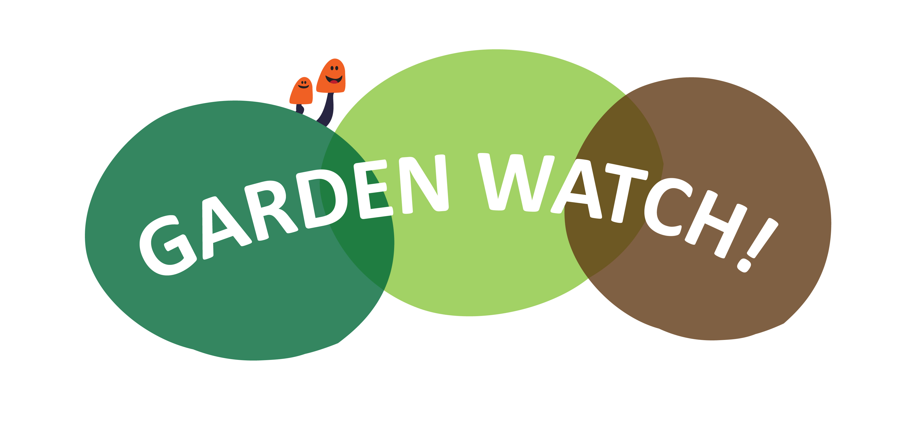

Dear Parents/Carers,

This Summer term we are setting our children the **Garden Watch** **Wildlife Challenge**! ‘**Garden Watch’** runs through the Summer term and focuses on raising awareness of the range of wildlife in our gardens and community. To help with the challenge, the children have all been given a **‘Garden Watch’** survey and activity booklet…

**So what do we do?**

The children have been asked to practice their scientific skills by carefully observing and recording the wildlife currently at large in their gardens! Please help your children to complete the survey in their Activity book on date to help us get a snapshot of what wildlife we currently have in our community. The children’s survey/challenge booklets should then be **returned to school** to so we can collect all the survey results!

**What next?**

‘Garden Watch’ challenges the children to think about how to encourage wildlife into their gardens. Please help the children to think about and decide what they will do (an example might be to make small animal habitats or simple feeder stations). The ‘Garden Watch’ booklets give plenty of information and links to help with ideas. The challenges the children complete should be recorded in their activity booklet using pictures, photos, writing, diagrams etc. on page 6! **Children should complete their garden activity as soon as possible after the first survey!**

**Garden Watch Finale!**

This is a chance for children to practice more scientific skills! Please help your children to complete their ‘Garden Watch’ survey No 2 in their activity booklets on date **.** The survey results will again be returned to school to collate all the information. The children will be tasked to scientifically analyse the data they have collected and discuss their findings, seek reasons and ask further questions about the results.

We hope that you will join us in the great ‘**Garden Watch Wildlife Challenge’** to really raise the bar of wildlife awareness in our community!

Kindest regards

*The School name Team*!

#Gardenscience

