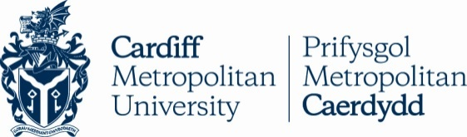 **TAPS Cymru Plan for Focused Assessment**

|  |  |  |  |
| --- | --- | --- | --- |
| **Science and DT topic:** Materials or Forces | Year 6  Age 10-11 | | Title: Bridge Engineers |
| **Enquiry Focus**  Ongoing evaluation of outcomes | | **Concept context**  Consider how tension and compression forces affect the strength of a bridge | |
| **Assessment Focus**   * Can children evaluate their progress during construction and adapt their design accordingly? * Can children evaluate their final outcome in terms of forces? | | | |
| **Activity** *Today we will be structural engineers.*  Intro/previous lesson: Demonstrate a simple beam bridge with a sponge: the top edge is being squashed (compression force) and the bottom edge is being stretched (tension force). Explore pictures of different types of bridges (e.g. beam, concertina, truss) and discuss how triangles can help spread the load when building bridges.  Group challenge: design and make a bridge which can hold the maximum weight.  Discuss and agree: materials available (e.g. drinking straws and sellotape); success criteria (e.g. width of bridge span, free-standing or stuck to table, test objects – coins/masses/books); safety measures (e.g. box under bridge during testing).  Mini-plenary at an appropriate point to share feedback.  Focused recording: teacher observation notes or pupils annotate design/photo to label changes, forces and evaluate outcome.  **Adapting the activity**  **Support:** pictures of examples, pause to magpie ideas  **Extension:** suspension bridge  **Other ideas:** try different materials, try a wider span  **Questions to support discussion**   * What kind of bridges could we make? * How could you strengthen your bridge? How could you spread the weight? * What have you changed about your design? * How often did you test your model? | | | |
| **Assessment Indicators**  **Not yet met:** Pupils focus on the making of the bridge with little evaluation e.g. do not do ongoing checks or adapt their design.  **Meeting:** Pupils use ongoing evaluation and testing to develop their design/model in response to test data e.g. how many coins it held.  **Possible ways of going further:** Pupils can explain how and why they adapted their original designs and suggest further ideas for improvements, giving reasons based on their findings or in terms of forces/properties of materials. | | | |

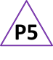

Pupil box 5 - act on feedback. See TAPS pyramid for more examples.