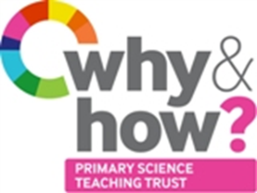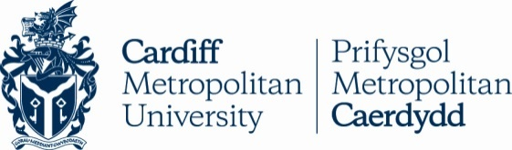 **TAPS Cymru Plan for Focused Assessment**

|  |  |  |  |
| --- | --- | --- | --- |
| **Science and DT topic:** Materials (or Forces) | Year 3  Age 7-8 | | Title: Egg drop packaging |
| **Enquiry Focus**  Evaluate outcomes against success criteria | | **Concept context**  Properties of materials relating to their uses | |
| **Assessment Focus**   * Can children explain how the approach/method was successful? * Can they describe any amendments or suggest how the approach/method could have been improved? | | | |
| **Activity** *Today we will be engineers.*  Gather a selection of materials for the children to design and build a package which will safely transport eggs without breaking.  Select a context to share with the children e.g. egg drop onto island, ‘eggstranaut’ landers.  Discuss how to make a fair comparison between the egg packaging designs - height to drop from and surface to drop onto.  Agree time, resources available and whether there is a group limit (e.g. 1x balloon, 1x plastic cup, paper, tape, 1 x carrier bag/box, 1x bubble wrap/foam/shredded paper).  Test each group’s design and reflect on success criteria.  Ask the children to make suggestions for future improvements, explaining why.  Focused recording: label photo or diagram noting successes, amendments and improvements.  **Adapting the activity**  **Support:** Limit the amount of resources to choose from.  **Extension:** Try other ways to test the packaging. Construct a safe package using less resources. Investigate traditional packaging materials and compare effectiveness to own design.  **Other ideas:** Provide a basic kit and budget with a list of additional components which they can ‘buy’. Challenge the children to ‘spend’ the least amount of ‘money’.    **Questions to support discussion**   * What type of materials would provide suitable protection? * How big does the package need to be? * Should everyone test their packages in the same way? * Are there any safety factors we need to consider? * How will we know if the packaging is successful? * What have you changed about your design? Why? | | | |
| **Assessment Indicators**  **Not yet met:** Can say if egg landed safely or not, but does not link this to properties of materials or the way their design was constructed.  **Meeting:** Apply their knowledge of materials when evaluating. Explain amendments to design and how these impacted on protecting the egg.  **Possible ways of going further:** Ongoing evaluation during designing, making and testing. Makes links with real life packaging designs. | | | |

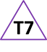

Teacher box 7 - time to reflect. See TAPS pyramid for more examples.