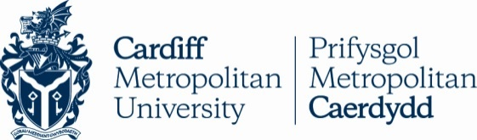 **TAPS Cymru Plan for Focused Assessment**

|  |  |  |  |
| --- | --- | --- | --- |
| **Science and DT topic:** Boats | Year 2  Age 6-7 | | Title:  Boat materials |
| **Enquiry Focus**  Describe what they have found out and use their results to make comparisons | | **Concept context**  Properties of materials relating to their  uses | |
| **Assessment Focus**   * Can the children describe what they have found out about the materials/design? * Can the children use their observations and scientific ideas to compare the boat materials? | | | |
| **Activity** *Today we will be nautical engineers.*  Discuss context/problem e.g. a boat to carry Handa’s fruit.  Share ideas for solutions and the kit available e.g. paper, card, foil, fabric, cellophane etc.  Work in groups to carry out challenge e.g. to make a boat which could carry an orange.  Pause to share ideas and discuss problems (adapting remit if needed).  Discuss the materials and designs whilst testing the boat designs in a large container of water.  Ask children to talk about / draw a diagram / write about their findings, with a focus on comparing the materials/design for the purpose of making a boat.    **Adapting the activity**  **Support:** Provide examples, limit the amount of kit available, provide support in recording.  **Extension:** Offer more independence, use counters/marbles/weights etc to measure load.  **Other ideas:** Challenge to make boat which carries the most weight or lasts the longest in water.    **Questions to support discussion**   * Which materials did you use in your boat? * What did you find out about the materials? * What kind of material/design worked the best? How did you know? * Why do you think that material worked best? * Which material would not be good for the boat? * What materials would you recommend to the Handa etc? Why? * Are there any materials that you think are good and bad? Explain why. | | | |
| **Assessment Indicators**  **Not yet met:** Can say whether boat worked or not but does not discuss any features of materials or design to explain why.  **Meeting:** Uses results to explain why some materials would be better than others for making a boat, in terms of their properties e.g. *the foil was good because it was waterproof and strong, paper is bad because it rips when it gets wet, the plastic bag floated for a long time.*  **Possible ways of going further:** Uses results to support explanations (e.g. how many marbles each boat held). Considers how some materials are good in certain circumstances e.g. *the card is good for a little while but it will get soggy later, the foil makes a good boat shape but the hole in the corner made it sink, when we blew up the bag it was really good but the marbles just rolled off so it needs some edges.* | | | |

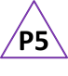 Pupil box 5 - act on feedback. See TAPS pyramid for more examples.