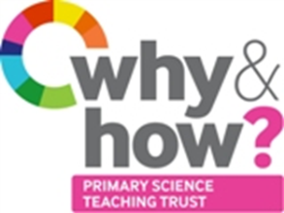
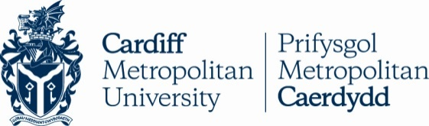
TAPS Cymru Plan for Focused Assessment
Science and DT topic: Materials or Forces | Year 1  Age 5-6 |  | Title: Bridge testers
Enquiry Focus  Collect data to compare bridges |  | Concept context  Properties of materials: strength of bridge shapes
Assessment Focus
- Can children collect data to measure bridge strength using pennies (or equivalent)?
- Can children use their data to compare bridge shapes?

Activity Today we will be engineers.
Show pictures of different types of bridges (local if possible). Discuss similarities and differences between e.g. Flat or beam bridge, Arch bridge, Beam bridge and Concertina bridge.
How do we find out which bridge shape is the strongest? Discuss and select: paper or card, A4 or other, test objects to place on model bridge.
Discuss success criteria for a fair comparison which groups will need to decide upon: same number of books on each side, same gap, same test objects (pennies/blocks etc).
Could allocate group roles e.g. Resource manager, Fair comparison checker, Test object counter, Group reporter.
What should we record? E.g. number of pennies before the bridge falls. Children to record results in a table. After testing ask children to identify the strongest and weakest bridge shape.
Could compare results from different groups and discuss reasons for differences.

Adapting the activity
Support: Provide support to make the paper/card bridges. Test one bridge together.
Extension: Try different bridge spans. Convert pennies into grams to measure the strength of the bridges.
Other ideas: Bridge for particular purpose e.g. insect crossing. Explore bridges using natural materials outside.

Questions to support discussion
- Which bridge shapes are we testing?
- How will we know which bridge shape is the strongest?
- How can we make it a fair comparison?
- How many pennies do you predict this bridge will hold?
- How will you know when to stop counting the pennies? Where will you write that down?
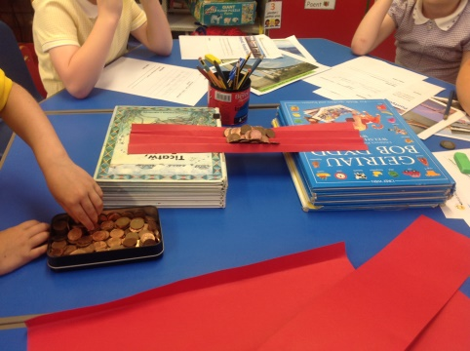
- Which bridge shape did you find to be the strongest? The weakest?
- What do you think makes a good bridge?

Assessment Indicators
Not yet met: Counts pennies, but does not link this to bridge strength without support.

Meeting: Collects data in a table. Uses their data to explain which bridge shape is the strongest and the weakest.

Possible ways of going further: Begin to compare and evaluate the data they have collected, or the data of others, for example, noticing the importance of keeping the bridge span the same.

