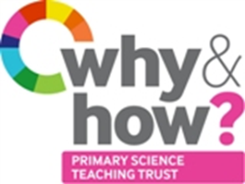**TAPS Plan for Focused Assessment of Science**

|  |  |  |  |
| --- | --- | --- | --- |
| **Topic:** Plants | Year 1  Age 5-6 | | Title: Leaf looking |
| **Working Scientifically**  Observing closely | | **Concept context**  identify and describe the basic structure of a variety of common flowering plants, including trees | |
| **Assessment Focus**   * Can children observe closely and make an accurate representation of a leaf that they have found? * Can children describe features on their leaf? | | | |
| **Activity** *Today we will be botanists.*  Go on a ‘welly walk’ in school grounds to collect leaves *(with clear instructions about where they are allowed to go and what they are allowed to collect/pick e.g. try to collect fallen leaves, do not over-pick from one plant, warn to look for prickles and stinging nettles etc – check with an adult if unsure).*  Use magnifiers to look closely at the leaves and ask pairs to discuss what is the same/what is different. Draw a leaf, labelling with support.  At an appropriate point, you could include a mini-plenary in which you show a drawing by the class teddy/puppet. Ask the children to give advice on how to improve the drawing e.g. *what colour is the leaf stalk? Where do the veins really go?*  Children could then improve their own or do another drawing.  Wash hands.  **Adapting the activity**  **Support:** Adult prompts to look carefully at veins, hairs, colour etc.  **Extension:** Label parts of the leaf, e.g. veins, hairs. Compare two leaves.  **Other ideas:** Provide some unusual leaves (or pictures), e.g. composite leaf, cactus, grass. Collect a nature paint pallet: stick small bits onto a card strip (with double sided tape on.)  **Key Questions**   * What does a leaf look like? * How are these leaves different/similar? * What shape/colour is your leaf? * Where did you find your leaf? How do you think it got there? * Does you leaf have hairs/veins? Why do you think they are there? * Does your leaf look the same on both sides? | | | |
| **Assessment Indicators**  **Not yet met:** Children draw a leaf but shape may not be accurate or features are missing  **Meeting:** Children can draw a leaf outline accurately and show hairs/veins when present.  **Possible ways of going further:** Children compare the features of different leaves. | | | |

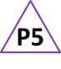

Pupil box 5 - act on feedback. See TAPS pyramid for more examples.