

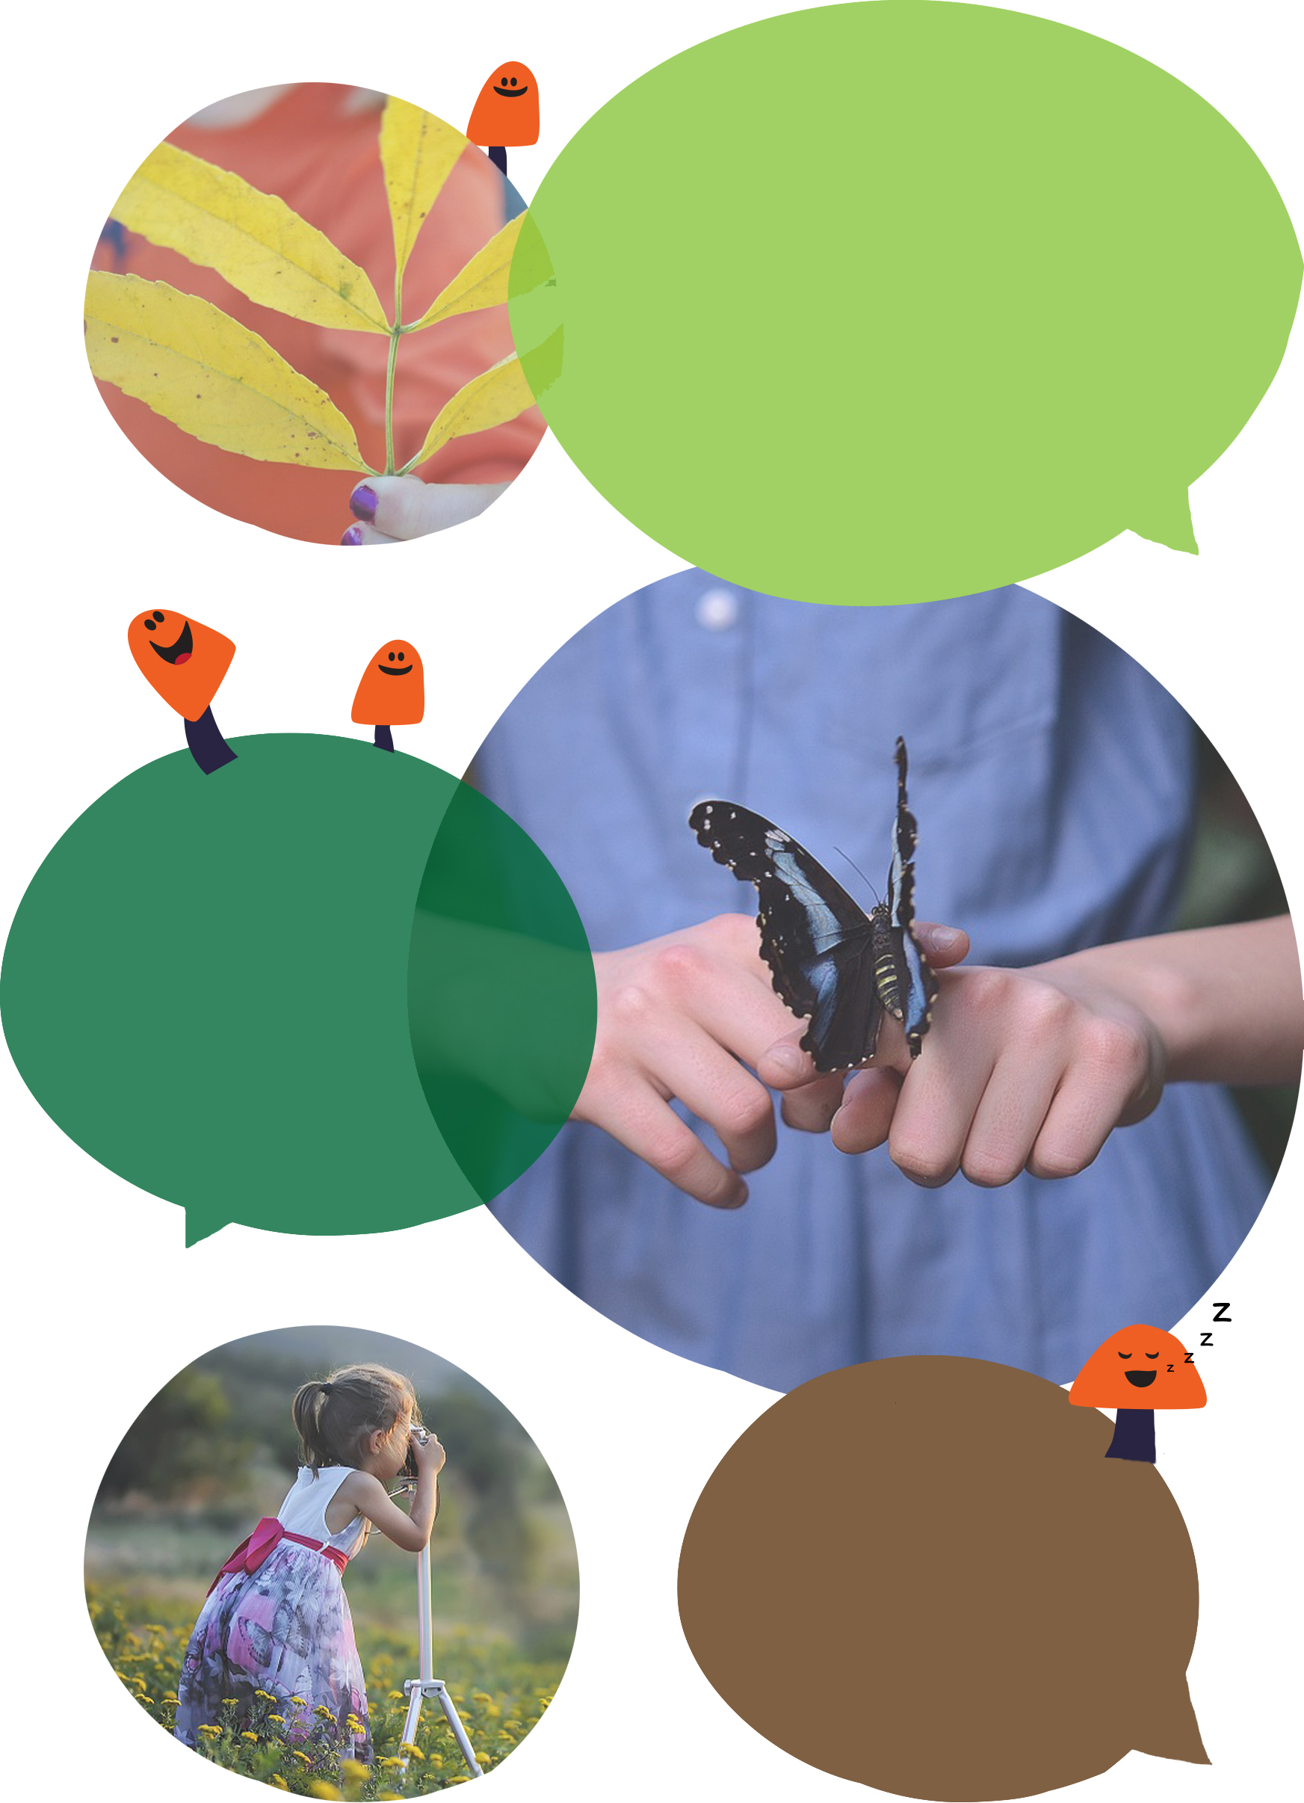
What did
you do?

Show what you
did in your garden
by drawing, writing,
sticking pictures…

‘Nature is struggling,
but if we all pull together and
do small actions for wildlife in our garden and outdoor spaces, we can
make a real difference. After all,
if there's no home for nature,
there will be no nature.’
(RSPB – Give nature a home)
Can you attract more
wildlife into your garden?

What wildlife
would you like to attract?

What will you do?
Try one (or more) of these activities in your own gardens.

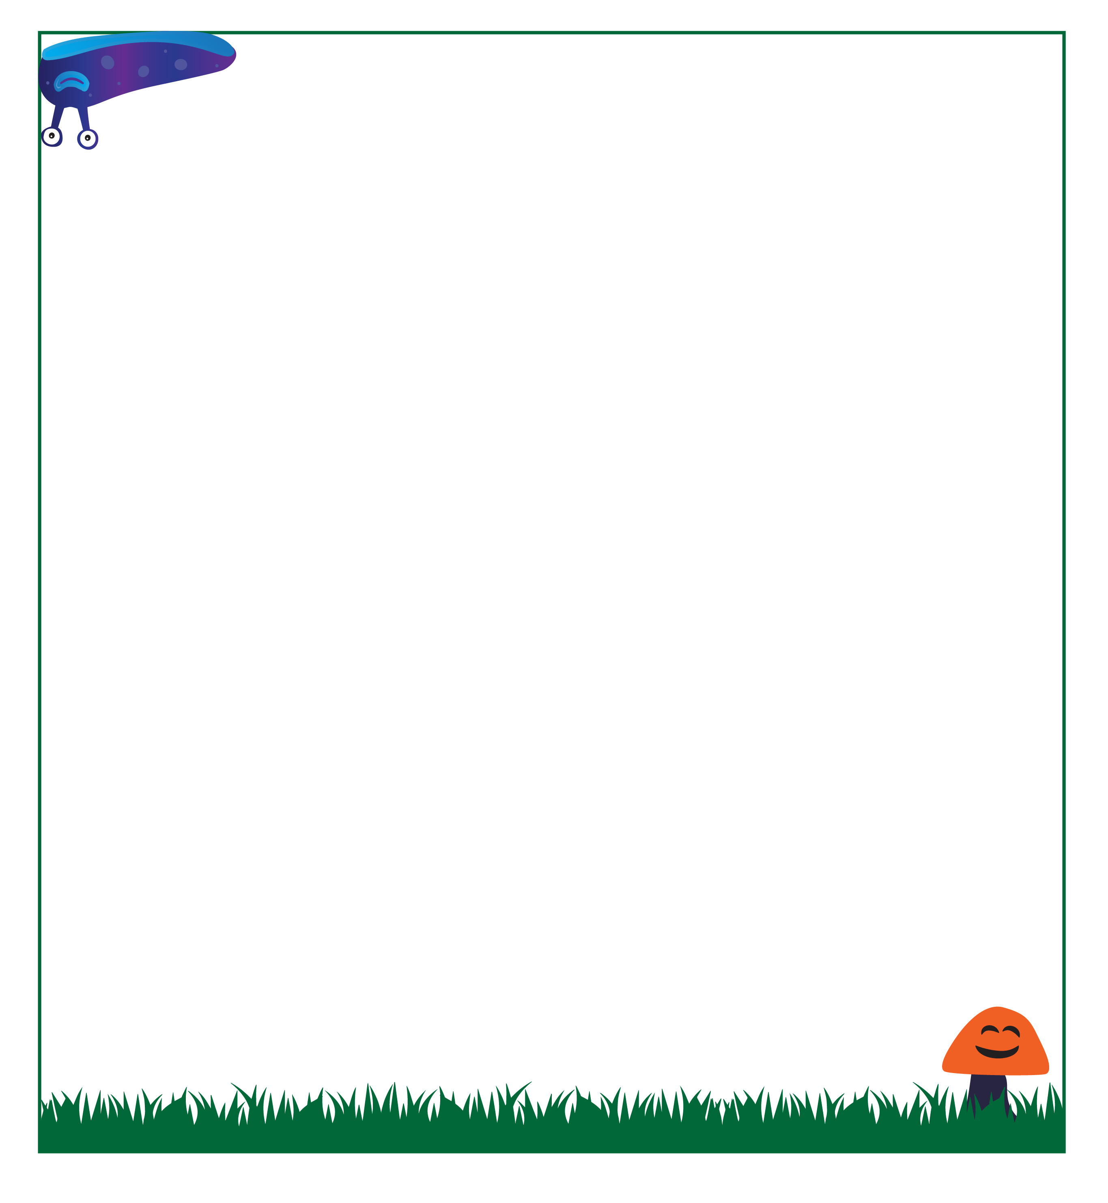
6
3

