


- What did you see?

Name | Name

Bring your survey back to school as soon as you have completed it.
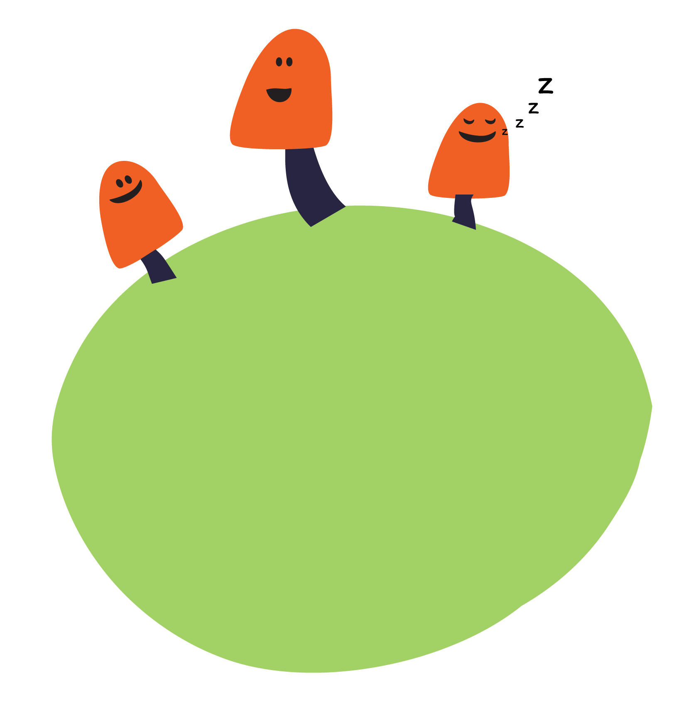
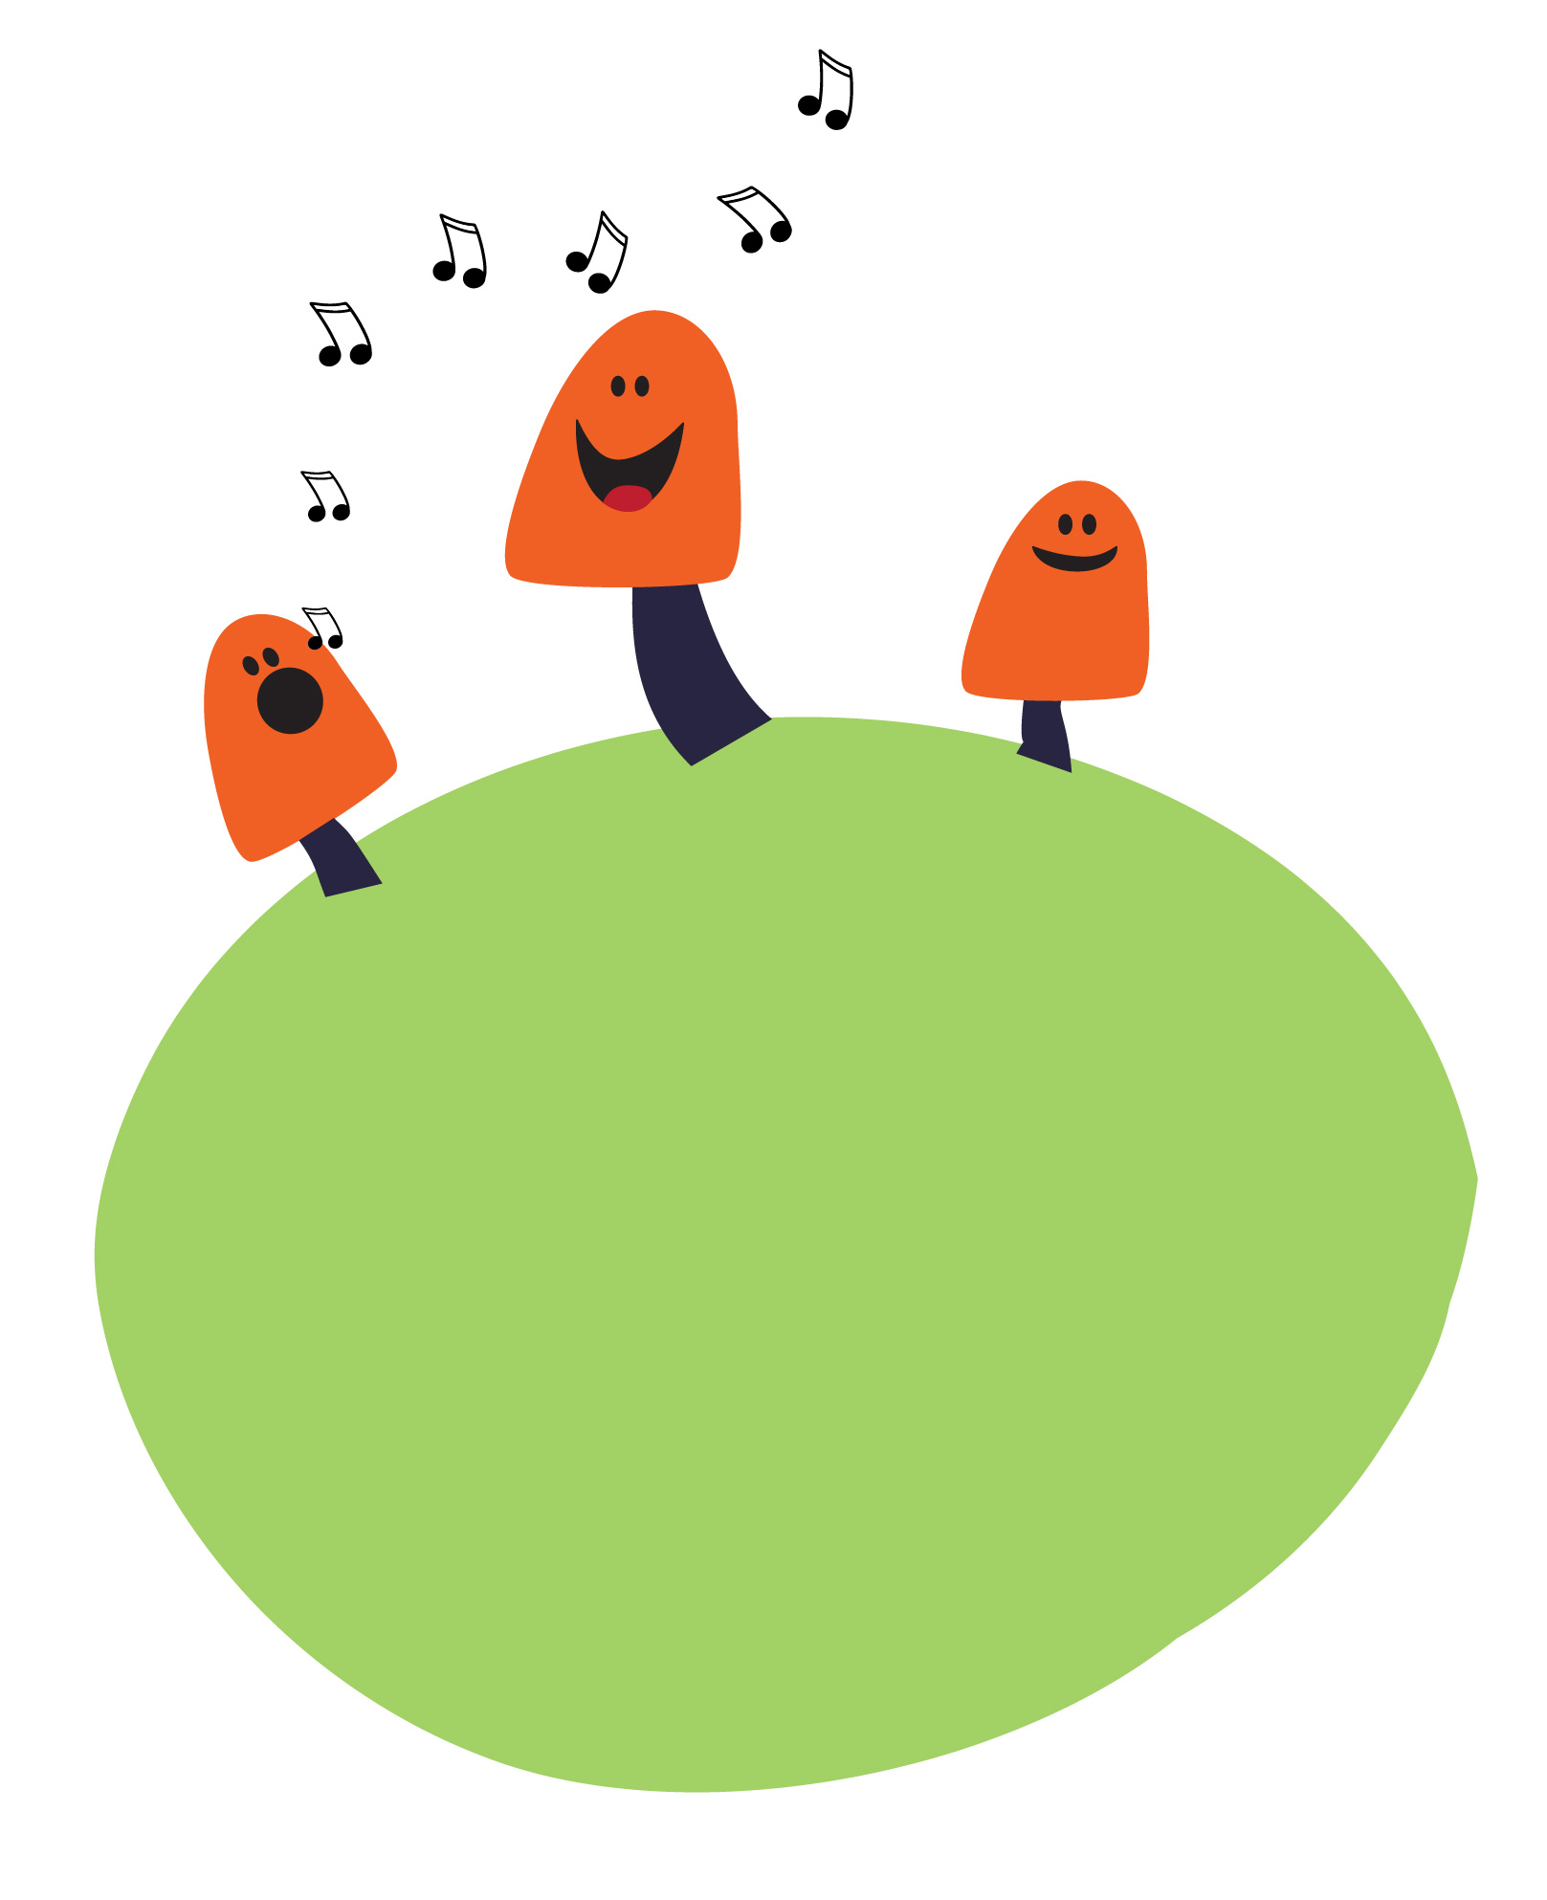

Survey 1

Fill in the table showing all the wildlife (animals, birds, insects) you see when you investigate your garden!

Date:

Survey 2
Let’s see if it’s different!

This time fill in
the table on…

Date:

- What did you see?

Name | Name

Don’t forget to bring your survey back to school. Lets compare!

2
7

