TAPS Plan for Focused Assessment of Science

Topic: Plant Growth | Year 3  Age 7-8 | Title: How much water do plants need?
Working Scientifically  Do: Making systematic and  careful observations and measurements using standard units |  | Concept Context  Explore the requirement of plants for life and growth, and how they vary from plant to plant.
Assessment Focus
- Can children use simple apparatus to measure water/height?
- Can children record their measurements?
Activity Today we are botanists.
Ask, how much water do these plants need to grow? Discuss how to set up an investigation as a whole class. Either draw on previous maths work or teach the children how to measure volume of water and the height of the plant. As they carry out the investigation, the children will need to make their own measurements of the water and the plant and record the height of the plant. Provide beakers/measuring cylinders, but amount of water should be easy to measure, e.g. 200ml, expect measurement of length to the nearest half cm.
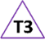
Over the course of the investigation, plan to check groups measuring the water and plant to observe their accuracy (TA support would be helpful here). Children could also peer check measures. Ask the children to explain why accurate measurements are important.

Adapting the activity
Support: Provide water containers with a single level marked. Provide rulers/card strips with cm coloured stripes that can be counted.
Extension: Provide beakers/measuring cylinders, but amount of water to measure involves understanding of the scale, e.g. 130ml. Independent choice of measuring equipment for length, but expect to nearest mm.
Other ideas: Link to measuring in maths.
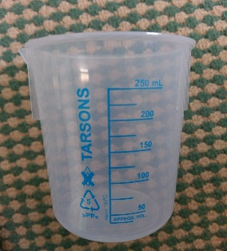
Questions to support discussion
- How much water shall we give the plants?
- How shall we measure how much the plant has grown?
- How can we make sure that we know how much water we have given them?
- Can you show me how you measure the water?
- Can you show me how you measure the plant?
- Why do we need to be accurate when we measure the water/plant?
- Ext: What is the importance of being accurate when taking measurements?
Assessment Indicators
Not yet met: With support, can measure a volume of water and height of the plant (to nearest cm).

Meeting: Can measure accurately the volume of water (to nearest 10 ml) and height of a plant (to nearest half cm).

Possible ways of going further: Measures accurately volume of water given to plants, and heights (mm). Explain importance of and suggests ways to improve accuracy (repeat readings).
Teacher box 3 - use Q, discussion & observation. See TAPS pyramid for more egs.

