TAPS Plan for Focused Assessment of Science

Topic: Light | Year 3  Age 7-8 | Title: Can everything make a shadow?
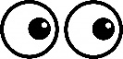  Working Scientifically  Do: Gather and record data to answer questions. |  | Concept Context  Recognise that shadows are formed when the light from a light source is blocked by an opaque subject.
Assessment Focus
- Can children make a series of careful observations?
- Can children record their observations in a systematic way that relates to the question?
Activity Today we are going to be physicists
Provide the children with a collection of materials to explore (some transparent, some translucent and some opaque).
Ask the children to investigate which materials form shadows when a torch is shone on them (e.g. colour, darkness, no shadow?)
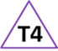
Ask them to record their observations to answer the question about which materials form a shadow (e.g. draw, write, sort, photo, order, table). Can they categorise or order the materials and/or shadows in some way?
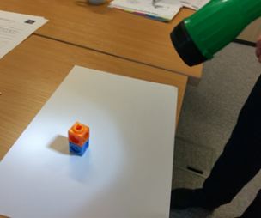
Adapting the activity
Support: Prompt children to describe shadow & scribe their comments.
Extension: Challenge the children to characterise the differences they observe between the shadows e.g. pale / dark.
Other ideas: Make shadow puppets with opaque and translucent parts.

Questions to support discussion
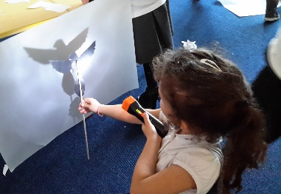
- Where will you write down the materials you are testing?
- How will you record what you have seen?
- What would be a good heading for this column?
- Does this material form a good shadow?
- What do you notice about this material/shadow?
- Where have you recorded what happened with this material?

Assessment Indicators
Not yet met: Can use their observations to decide whether or not a shadow has been formed by the material, e.g. has sorted materials into two piles or recorded tick/cross.

Meeting: Can make observations and decide how to record them to answer the question, e.g. independently records best to worst shadow.

Possible ways of going further: Recording communicates clearly how it answers the question, using appropriate vocabulary such as opaque, translucent and transparent.

Teacher box 4 - gather evidence in a range of ways.
See TAPS pyramid for more examples.

