TAPS Plan for Focused Assessment of Science

Topic: Forces | Year 3  Age 7-8 |  | Title: Shoe Grip
Working Scientifically  Plan: Set up simple practical enquiries |  | Concept Context  Some forces need contact between two objects
Assessment focus
- Can children plan and set up a fair test?

Activity Today we are going to be materials engineers
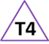
Invite children to examine a collection of shoes and to look at the shoe’s grip. Ask children to plan (in small groups) their own way of testing the shoe’s grip but give teacher support where needed. Have useful equipment visible, e.g. ramps (for lifting until the shoe slips), Newton meters (for pulling). A further option could be for runs across the hall to be timed wearing shoes, trainers, socks and bare feet. Record the plans in words and/or diagrams.

Adapting the activity
Support: Ask children to explain what they are changing and what they are keeping the same each time. Could focus on comparing just two shoes & explaining why one slides more easily than the other.

Extension: Ask the children to explain how their plan will be a fair test and any limitations to ensuring this.

Other ideas: Children could explore how shoes perform on different surfaces.

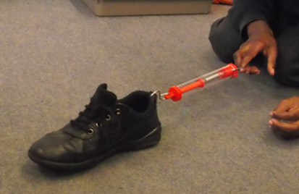
Questions to support discussion
- How can we find out which shoe has the best grip?
- What could we measure?
- What would you need to keep the same to make your test fair?
- Is your plan working, or did you need to adapt it?
- Which shoes had more grip? How do you know?
- Which shoe needed the most force/tilt of the ramp? Why could that be?

Assessment Indicators
Not yet met: Can make suggestions about how to answer the question, and with support, can devise a simple test. Needs support to explain what has to be kept the same.

Meeting: Can devise a way of answering the question. Can say what was changed and what was kept the same.

Possible ways of going further: Can give examples of other independent variables to test and suggest a comparative test to investigate these, e.g. different surfaces, different angles of the ramp. Can explain the limitations to keeping all other variables the same e.g. When we change the type of shoe the mass or type of material may also affect the grip but we are unable to control these.

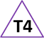
Teacher box 4 - gather evidence in a range of ways.
See TAPS pyramid for more examples

