TAPS Plan for Focused Assessment of Science
Topic: Forces | Year 3  Age 7-8 | Title: Cars down ramps
Working Scientifically  Do: Gather, record and  present data (in a table or bar chart) to help in answering questions |  | Concept Context  Compare how things move on different surfaces
Assessment Focus
- Can children make an accurate record of their measurements?
- Can children use their results to explain how the car moves on different surfaces?
Activity Today we are going to be mechanical engineers
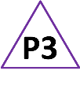
Discuss the purpose of an escape lane and the kind of surfaces which could be used to slow down vehicles. Explore how far cars go after a hill (down a ramp) which is sitting on the carpet. In small groups discuss how they will measure how far the car goes on different surfaces and how they can record this. Emphasise that we are testing the surface, so everything else must stay the same to be fair – as a class, list the control variables.
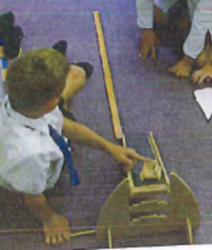
Generate success criteria with the children for drawing tables. Groups investigate with each drawing their own results table. Children could self assess their results tables against the success criteria.
Ask children to explain how the surface makes a difference.

Adapting the activity
Support: Ask questions to prompt groups to think about the accuracy of their measurements and the clarity of their recording.

Extension: Children take repeat readings and compare them with their original measurements.

Questions to support discussion
- How do you think it will be different if we move the ramp to the table?
- What if we put a cloth/books/foil/blanket/wood at the end of the ramp?
- How will we know if it makes a difference? How will we measure?
- What do we need to do to keep it fair?
- What will you write down? Could you draw a table ready to collect the distances?
- Where on your table is the result for the carpet etc?
- Can you put your findings on a bar chart?
Assessment Indicators
Not yet met: Measures distance with the equipment provided, recording with support. Predictions/explanations describe how things move (in isolation) e.g. the car goes fast on plastic.

Meeting: Takes and records accurate measurements using standard units and presents findings in a table (or bar chart). Can compare how things move, e.g. it goes quicker on wood and slower on grass.

Possible ways of going further: Systematically takes repeat readings and records all measurements in a table or bar chart. Can explain findings in terms of friction or describe general patterns e.g. it will go further on a smoother surface because bumps slow it down.
Pupil box 3 - assess own ideas. See TAPS pyramid for more examples.

