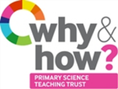
TAPS Plan for Focused Assessment of Science

Topic: Living things and their habitats | Year 2  Age 6-7 | Title: Feeding simulation
Working Scientifically  Do: Perform simple tests, observe closely | Concept Context  Describe how animals obtain their food from plants and other animals, using the idea of a simple food chain, and identify and name different sources of food.
Assessment Focus
- Can children carry out a simple test to simulate feeding?
- Can children observe closely to collect data?
Activity We are going to be environmental scientists.
Discuss how different animals feed and what they feed on, linking to other lessons on food chains and feeding as a life process (something that all living things do).
Introduce feeding simulation: use finger ‘beaks’ (thumb and forefinger) to ‘feed’ (grab as much food as they can from a mixture and put onto a plate) for a set time e.g. 20 seconds until predator spotted.
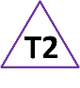
Provide each pair/group with a feeding mixture in a bag or small pot. For example:
- Food: small pasta, popcorn maize, bird seed
- Plastic ‘food’: plastic beads, bits of plastic bags or straws
Could do class stop/start feeding timings, or do in small groups e.g. 1 feeder, 1 timer, 1 recorder, 1 sorter. Ensure time to observe and classify the ‘food’ that they collected. Record how much food and plastic/not-food has been ‘eaten’ after each feeding session.
Share findings and discuss what could happen to wildlife if they ate this mixture.

Adapting the activity
Support: Provide a small number of the larger items of ‘food’ to grab and sort.
Extension: Try ‘scoop’ feeding in water or sand. Further research about the effects of plastic pollution.
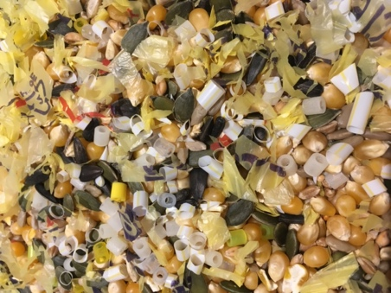
Other ideas: Create a poster or video to discourage littering/ plastic pollution, or to encourage saying ‘no’ to one (or all!) of the Big 4 plastic polluters (coffee cups, straws, plastic bottles, plastic bags).

Questions to support discussion
- How much of each type was collected?
- Can all of this mixture be eaten safely?
- What might happen if an animal ate this mixture?
- Which bits of the mixture can be digested?
- Where might the plastic pieces come from?
Assessment Indicators
Not yet met: Children have difficulty performing the test, e.g. trouble sorting or counting the ‘food’.

Meeting: Children meeting the objective would be able to follow instructions to carry out the simulation and observe closely to sort the ‘food’.

Possible ways of going further: Children may consider the implications of repeatedly feeding in a plastic-rich environment. They may consider other implications e.g. plastic around feet/wings etc. They may go on to do their own research about the main plastic pollutants in the ocean.
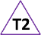 Teacher box 2 - discuss objectives and criteria. See TAPS pyramid for more egs.

