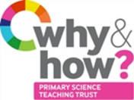
TAPS Plan for Focused Assessment of Science
Topic: Living Things | Year 2  Age 6-7 |  | Title: Sorting living and non-living
Working Scientifically  Review:  Use of appropriate scientific language to communicate their ideas |  | Concept Context  explore and compare the differences between things that are living, dead, and things that have never been alive
Assessment Focus
- Can children identify differences between things that are living, dead, and things that have never been alive?
- Can sort things into living and non-living, or living, dead and never alive?
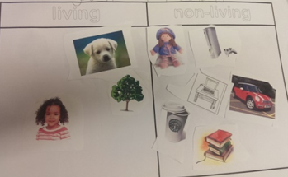
Activity Today we are zoologists.
Provide a range of objects and pictures to explore, including some plants. Use sorting hoops or similar to explore ideas about which are alive now, which used to be alive and which have never been alive.
Ask the children to explain how they decide, drawing out characteristics of living things. Ask them to continue sorting and add their own ideas.
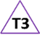
Explore any new ideas and address any misconceptions.

Adapting the activity
Support: Provide pictures or objects which clearly fit into one category to start with.
Extension: Provide additional examples which are less clear e.g. seeds, paper, snail shell.
Other ideas: Take photos on a living/non-living hunt around school or home.
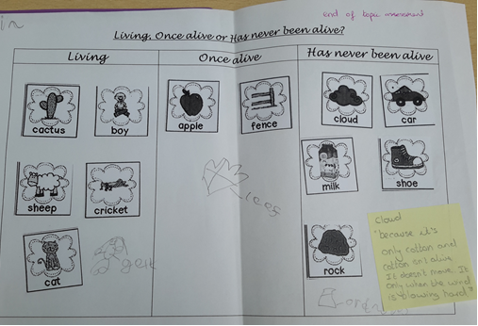
Questions to support discussion
- Are any of these alive?
- Did any of these used to be alive?
- Have any of these never been alive?
- How do you know?
- What else could go in that hoop?
Assessment Indicators
Not yet met: Children can sort items with adult support but are unsure when working independently, or they have not yet developed/able to express their ideas about living/non-living.

Meeting: Children meeting the objective would be able to explain why they had sorted in this way e.g. “because it moves on its legs and it would probably go and get something to eat and drink if it was hungry”, “it’s living because it can be pregnant and it can get a husband or wife”, “the rock doesn’t grow, eat, move or have babies”.

Possible ways of going further: Children explore ideas further e.g. the seeds can’t grow at the moment, but they will if you give them a drink (seeds can be dormant).

Teacher box 3 - use Q, discussion and observation. See TAPS pyramid for more egs

