TAPS Plan for Focused Assessment of Science

Topic: Plants | Year 2  Age 6-7 |  | Title: Comparing plant growth in different conditions
Working Scientifically  Do: Observe closely, using  simple equipment |  | Concept Context  Describe how plants needs water, light and a suitable temperature to grow and stay healthy
Assessment Focus
- Can children observe closely, noticing differences and similarities?
- Can children measure and compare the height of plants?
Activity Today we are botanists.
Show children pre-grown plants, discuss what children think these plants need to keep healthy. Raise questions they would like to investigate, e.g. How long can plants last without water / light? Does it matter if the plant is inside or outside? How will less light affect the plant?
Use pre-grown plants to explore conditions for growth, e.g.
Compare NORMAL CONDITIONS (on window sill + water + light + warm) with:
No/less/more WATER or No/less/more LIGHT or No/less/more WARMTH.
Discuss what they think will happen to plants without water/sun/warmth and how to record observations e.g. labelled drawings every few days to make plant diaries.
Children need to observe and measure the plants over time using simple equipment e.g. cameras, rulers, measuring tape, magnifiers.
Discuss what the class results show about what a plant needs to grow and to stay healthy.
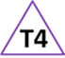
Adapting the activity
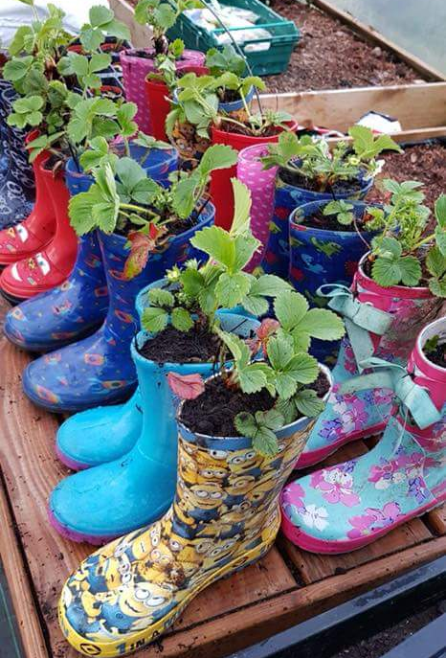
Support: Compare just one of the requirements (e.g. water/no water), record with photos as well as drawings.
Extension: Accurately measure a range of features and record in a table.
Other ideas: Investigate different plants.

Questions to support discussion
- What do you notice about the plants? Can you see any differences?
- Why might the plants look different?
- What similarities are there between the plants?
- How are we going to observe the differences over time?
- What will we record?
- Have our results answered our question? Why?
- What does a plant need to grow?
Assessment Indicators
Not yet met: Describes observable differences at the time of asking e.g. which plant is the tallest and shortest.

Meeting: Observes and records the appearance of the plants over time (drawing or annotated photo). Can compare the height and/or features of the plants over time e.g. this one was fine to start with but now it’s much smaller.

Possible ways of going further: Make a range of comparisons between the plants in different conditions, e.g. colour, droopiness, height, number of leaves.
Teacher box 4 - gather evidence in a range of ways. See TAPS pyramid for more egs

