**TAPS Plan for Focused Assessment of Science**

|  |  |  |  |
| --- | --- | --- | --- |
| **Topic:** Materials  or Forces | Year 2  C the children edge FocususAge 6-7 | | Title: Rocket mice |
| Logo for doing strand of Working Scientifically**Working Scientifically**  **Do:** Perform simple tests to answer questions | | **Concept context**  Can link to materials (properties, uses, changing shape) or forces | |
| **Assessment Focus**   * Can children begin to be systematic in their testing? * Can the children use their tests to suggest answers to questions? | | | |
| **Activity**  Demonstrate rocket mouse: put pre-made mouse on top of plastic bottle and whack bottle with both hands. Template at: <http://www.sciencemuseum.org.uk/educators/teaching_resources/activities/rocket_mice.aspx>  Children make rocket mice and explore/test out. Consider whose mouse went the furthest. Prompt children to explain how they knew it went further. Collect children’s ideas for measuring e.g. hold next to a metre ruler, put a post it on the wall to show how high it got, shoot them across the floor (45° bottle) – this can create a ‘floor graph’.  Ask small groups to compare different sized bottles using their selected measuring method. Observe groups carrying out their tests.  Discuss findings, including how well their measurement techniques worked.  **Adapting the activity**  **Support:** provide very different sized bottles, shoot across floor  **Extension:** provide equipment for measuring independently  **Other ideas**: What if we add ears, a tail, a cape…which would/did go further?  From Science Museum resource. Hands hitting plastic milk bottle with paper mouse being pushed off the top  **Questions to support discussion**   * Which mouse went the furthest? * How do you know it went further? * Why do you think it did? * Can you measure how far/high it goes? * Does it go that far every time? * What if we try a different bottle/mouse? * How could we make it go even further? | | | |
| **Assessment Indicators**  **Not yet met:** Explores activity ‘in the moment’ e.g. without comparison between bottles or mice. Says which mouse went the furthest, but does not say why e.g. *it was Abi’s.*  **Meeting:** Beginning to compare systematically. Able to explain how they know which one went the furthest e.g. *it went up to there on the wall/floor last time,* *it’ll go higher than the metre stick.*  **Possible ways of going further:** May record measurements independently or note accuracy e.g. *we struggled to measure it because we didn’t have time to measure before they came down.* Notice patterns and explains scientifically e.g. between larger bottles and amount of air pushed. | | | |

[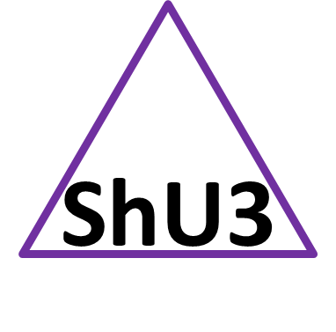](https://taps.pstt.org.uk/shared-understanding/)**This investigation can be for any age and can have a different Working Scientifically focus e.g. do across the school and look for progression.**

Shared Understanding box 3 – progression. See TAPS pyramid for more egs.