TAPS Plan for Focused Assessment of Science

Topic: Living things and their habitats | Year 2  Age 6-7 | Title: Woodlice habitat
Working Scientifically  Do: Gather and record data to help in answering questions. | Concept Context  Identify that most living things live in habitats to which they are suited and describe how different habitats provide for the basic needs of different kinds of animals and plants
Assessment Focus
- Can children gather and record data in a tally chart or on a map?
- Can children discuss their findings in relation to preferred habitats?
Activity Today we are a zoologists.
Discuss what a habitat is and different habitats e.g. use pictures of plants/animals and consider where they live. What about this creature? Show picture of a woodlouse (or substitute for another animal which is common in your context at the time of year).
What kinds of habitats do woodlice live in? Consider places in the locality where we could look for woodlice.
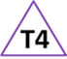
Decide whether to tally woodlice in different places or broaden to any invertebrates.
Support children to set up a tally chart or map ready to record their results.
Discuss expectations e.g. places allowed to visit, group/class, boundary, return signal etc.
Return to class to consider findings and discuss preferred habitats for woodlice.
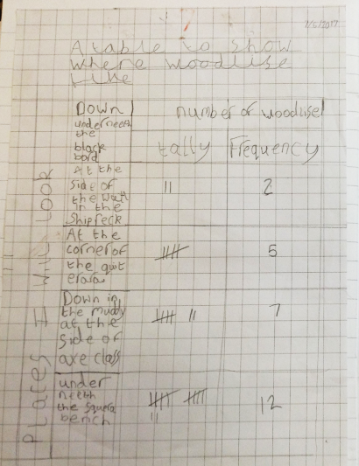
Adapting the activity
Support: Provide a table / map of the environment for recording data.
Extension: Record other living things which share the habitat and/or features of the habitat.
Other ideas: Maths link. Repeat in a different environment or season.

Questions to support discussion
- How are you going to answer the question?
- Where are you going to gather your data?
- How could you record which animal lives in which habitat?
- What does this part on your chart/map mean?
- Do any animals/ plants share their habitats? Why might this be? What are the characteristics of these habitats?
Assessment Indicators
Not yet met: Says how many woodlice were found, e.g. I found 3 woodlice. Needs support to record on a tally chart or map.

Meeting: Can draw a tally chart (after it’s been modelled to them) or record on a map and explain why woodlice are found in a particular habitat, e.g. I found 3 here and 3 there because it is dark.

Possible ways of going further Can independently explain their tally chart / map, e.g. There are more spiders here and more woodlice there… Explaining why the woodlice might live there e.g. because of predators.
Teacher box 4 - gather evidence in a range of ways. See TAPS pyramid for more egs

