TAPS Plan for Focused Assessment of Science

Topic: Living things and their habitats | Year 2  Age 6-7 | Title: Nature spotters
Working Scientifically  Review: Identifying and classifying | Concept Context  Identify and name a variety of plants and animals in their habitats, including micro-habitats
Assessment Focus
- Can children use spotter sheets to identify plants/animals?
- Can children classify the types of plants/animals they have found?
Activity Today we are conservation officers.
Explore simple classification keys/spotter sheets – select appropriate for your local habitat (in or out of school grounds) and season, for example:
http://www.woodlandtrust.org.uk/naturedetectives/activities
Take the children on a nature hunt to explore the habitat. Groups could explore: leaves/blossom/trees, flowers, invertebrates (mini beasts), pond life... as appropriate.
Remind children about careful handling of animals, returning any creatures to their habitat, not picking wild flowers, not eating, washing hands on return. Children use spotter sheers to identify and classify plants and animals they encounter.
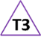
Return to class to discuss their findings. Classify the types of living things found, asking for reasons why their animal does / does not belong to a classification group.

Adapting the activity
Support: Provide a spotter sheet containing very common/easy to distinguish plants/animals.
Extension: Provide a more challenging spotter sheet where close observation is needed to spot the differences between the species.
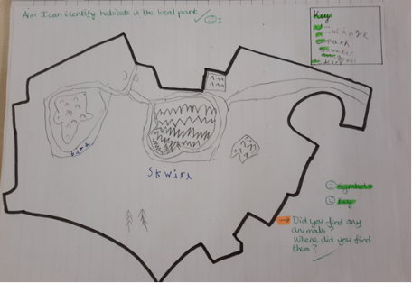
Other ideas: Visit a different habitat and compare findings.

Questions to support discussion
- What did we see on our walk?
- What kinds of plants/animals did we find?
- How did you identify this animal / plant?
- Did you see any signs that animals had been there?
- Which group does this animal / plant belong to? How do you know?
- Why is this animal not a ……?
Assessment Indicators
Not yet met: Children may name animals already known to them e.g. ants and spiders with little reference to the spotter sheets. Children will not yet be linking the specific animal to its features e.g. I know it’s an ant because we have them in my garden.

Meeting: Children use spotter sheets to identify plants or animals e.g. I think that is an earwig because it has a funny tail like on the sheet. Children begin to classify e.g. That woodlouse can’t be an insect because it doesn’t have 6 legs. The squirrel in the tree is all furry so it must be a mammal.

Possible ways of going further: Children can discuss the limitations of the spotter sheets e.g. I think it is a kind of ladybird because it has the same kind of back and legs, but it is not the same as on the sheet, but the sheet can’t have pictures of all the ladybirds.
Teacher box 3 - use Q, discussion and observation. See TAPS pyramid for more egs

