TAPS Plan for Focused Assessment of Science

Topic: Animals, Including Humans | Year 2  Age 6-7 | Title: Comparing hand spans
Working Scientifically  Review: Using their observations and ideas to suggest answers to questions |  | Concept Context  Recognise growth in humans.
Assessment Focus
- Can children use their observations to compare different hand spans?
- Can children use their observations to suggest answers to their questions about hand spans?

Activity Today we are an anatomists.
Ask the children to compare the size of their hand with that of another child. As a class create a list of questions e.g. Do older children have bigger hands? Do taller children have bigger hands? Can bigger hands pick up more cubes? (‘Handspan grab’ can create a graph of cubes).
Discuss how hand spans could be measured and agree as a class (e.g. draw around hands, spread/closed fingers, start and end place of measurement, to nearest centimetre). With a partner to help, ask each child to measure their own hand.
Record results together as a class.
Ask the children to compare hand spans and suggest reasons answers to the class questions.
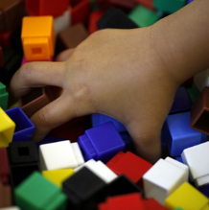
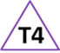
Adapting the activity
Support: Compare hand cut outs rather than measurements
Extension: What size hands would a Year 6 child have? Why?
Other ideas: Compare feet – do taller people have the biggest feet?

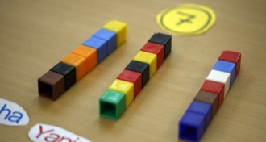
Questions to support discussion
- How can we accurately measure hand span?
- Who had the smallest/ biggest hand span in the class?
- What size hands did most children have?
- What do you notice about people with the biggest hand span?
- Did size of hands affect how many cubes were picked up?
Assessment Indicators
Not yet met: Can make simple comparisons, saying which hand is smallest or biggest.

Meeting: Can make comparisons using their observations/results to say which hands are bigger and smaller. Suggests reasons for differences in results e.g. his hand is bigger because he has had longer to grow, she holds more cubes because she spreads out her fingers far to grab them.

Possible ways of going further: Can make predictions relating hand span to height, e.g. a Year 6 will have bigger hands / will hold more cubes because....
Can raise further questions related to height that could be tested, e.g. when do your hands stop growing?

Teacher box 4 - gather evidence in a range of ways. See TAPS pyramid for more egs

