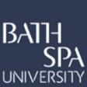
TAPS Plan for Focused Assessment of Science
Topic:  Materials/light | Year 1  Age 5-6 | Title: Ways to test reflectiveness  (alternative plan to transparency)
Working Scientifically  Plan: Recognise that sorting questions can be answered in different ways |  | Concept Context  Describe properties of materials
Assessment Focus
- Can children test the reflectiveness of materials?
- Can children compare materials on the basis of their reflectiveness?
- Can children discuss different ways to test reflectiveness?
Activity Today we are going to be physicists
(Could be done as a follow up lesson to transparency, if you would like to do more on this)
Explore a range of materials e.g. foil, shiny fabric, glossy acetate, shiny paper, brightly coloured paper, netting… list words to describe their properties on a whiteboard (e.g. shiny/dull, glossy, translucent/opaque).
Discuss how to test which are the most reflective, e.g. put in sunlight / torchlight / use a lamp, does it bounce off onto the wall/table? Can you see yourself in it?
Groups test and sort a range of materials (could be for a purpose, e.g. to find the most reflective materials for making our rockets in DT).
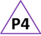
Children sit in a circle and consider one group’s sorting / ordering – do you agree? Would you move any? Why? Adult collect children’s ideas or ask target children or those who have not worked with an adult.

Adapting the activity
Support: Provide sorting hoops (reflect / not reflect). Adult to prompt children to describe and explain.
Extension: Can you test in a different way? Where would you put this tricky one? e.g. black plastic, coloured acetate (shiny and translucent).
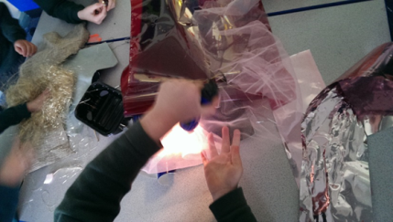
Other: Could test transparency or whether magnetic.

Questions to support discussion
- How could you test it?
- Which is the most or least reflective? How do you know?
- What other words could you use to describe the materials?
- Does everyone in your group agree?
- Can you explain to the others why you have put that material there?
- Can you tell me another way to test this object?
Assessment Indicators
Not yet met: Can sort materials into two groups but not clear or gives a reason for the sorting that does not link to very reflective/less reflective. Or may not use a single criterion to sort: “these are colourful, these are shiny”. May confuse reflection with other properties e.g. transparency or bright colours.

Meeting: Describe how they sorted the materials according to how reflective they are, and how other groups used different ways to sort the materials.

Possible ways to go further: Able to order the materials from most to least reflective and explain how the test helped them decide on this sequence. Can comment on effectiveness of different ways to test or compare the objects. May suggest what property of the material causes the reflectiveness.
Pupil box 4 - assess peers. See TAPS pyramid for more examples.

